Section A
For each question there are four possible answers, A, B, C, and D.
Choose the one you consider to be correct and shade your choice on the OMS provided.

1 | What volume of CO₂ will be formed when y cm³ of a 50:50 mixture of methane and propane is completely burnt?
 | A | 2y cm³ | B | 5y/2 cm³ | C | 4y cm³ | D | 5y cm³

2 | Which of the following ions has the smallest ionic radius?
 | A | F⁻ | B | Ne | C | Mg²⁺ | D | Al³⁺

3 | Which of the following statements describes a phenomenon which cannot be explained by hydrogen bonding?
 | A | Ice has a lower density than water at 0 °C.
 | B | The boiling point of alcohols increases with increasing relative molecular mass.
 | C | 2−nitrophenol is more volatile than 4−nitrophenol.
 | D | Ethanoic acid molecules form dimers when dissolved in benzene.

4 | A student used the apparatus below to determine the enthalpy change of combustion of propan-1-ol.  thermometer  calorimeter containing 200 g of water  burner containing propan-1-ol  The following results were obtained:  mass of propan-1-ol burnt = 0.60 g  mass of water heated = 200 g  initial temperature of water = 21.0 °C  Given that the enthalpy change of propan-1-ol is −2021 kJ mol⁻¹ and the heat capacity of water is 4.17 J K⁻¹ g⁻¹, what would be the final temperature of the water?
 | A | 24.2 °C | B | 29.1 °C | C | 45.2 °C | D | 48.4 °C

5 | Which treatment is frequently used to protect aluminium articles from subsequent corrosion?
 | A | Making the aluminium the anode during electrolysis.
 | B | Dipping the aluminium in hot aqueous sodium hydroxide.
 | C | Dipping the aluminium in molten cryolite.
 | D | Coating the aluminium with zinc.

6 | A piece of litmus paper was soaked in saturated NaCl solution and supported on a glass slide. The paper was connected to a battery as shown in the diagram below.  connected to positive electrode of battery  connected to negative electrode of battery  litmus paper  glass slide  Which of the following gives the observations near the negative electrode and positive electrodes after the current has flowed for some time?
 |  | negative electrode | positive electrode
 | A | no change | bleached
 | B | bleached | no change
 | C | red | bleached
 | D | blue | bleached

7 | The pK_{b} value for aqueous ammonia at 25 °C is 4.8.  What is the pK_{a} value for the ammonium ion at this temperature?
 | A | 2.2 | B | 4.8 | C | 9.2 | D | 11.8

8 | The rate of reaction of a strip of magnesium and 50 cm³ of 1.0 mol dm⁻³ HCl is determined at 25 °C. In which of the following cases would both new conditions contribute to an increase in the rate of reaction?
 | A | Mg powder and 100 cm³ of 1.0 mol dm⁻³ HCl
 | B | Mg powder and 50 cm³ of 0.8 mol dm⁻³ HCl
 | C | 100 cm³ of 1.0 mol dm⁻³ HCl at 30 °C
 | D | 50 cm³ of 1.2 mol dm⁻³ HCl at 30 °C

9 | The energy diagram represents the reaction occurring with and without a catalyst.  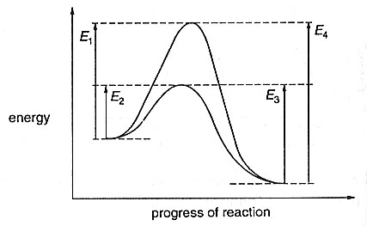  Which of the following statements is correct?
 | A | E₄ is the activation energy for the reverse catalysed reaction.
 | B | The forward reaction, with catalyst, is endothermic.
 | C | The enthalpy change of reaction is (E₂ − E₃).
 | D | The enthalpy change of reaction is reduced by using a catalyst.

10 | Which graph best shows the variation of first ionisation energy of the third period elements?
 | A | 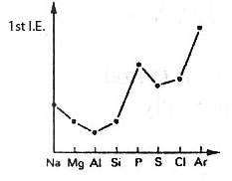 | B | 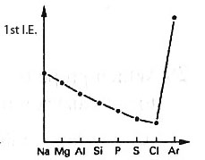
 | C | 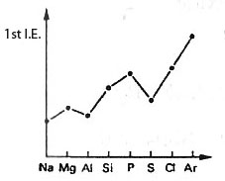 | D | 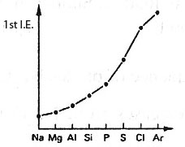

11 | Which of the following sets contains a basic, an acidic, and an amphoteric oxide?
 | A | Al₂O₃ | SiO₂ | P₄O₁₀
 | B | Na₂O | MgO | P₄O₁₀
 | C | Na₂O | P₄O₁₀ | SO₃
 | D | MgO | Al₂O₃ | SO₃

12 | It may be dangerous to put Group II metals in dilute acids since there is a possibility that explosion may occur. Which of the following best accounts for the above statement?
 | A | Ionic radius increases down the group.
 | B | Ionisation energy increases down the group.
 | C | Charge density increases down the group.
 | D | Reducing power increases down the group.

13 | Which of the following statements is most likely to be true for astatine, the element below iodine in Group VII of the Periodic Table?
 | A | Astatine and aqueous potassium chloride react to form aqueous potassium astatide and chlorine.
 | B | Silver astatide and dilute aqueous ammonia react to form a solution of a soluble complex.
 | C | Sodium astatide and hot concentrated sulphuric acid react to form astatine.
 | D | Astatine is a coloured liquid at room temperature.

14 | Both aqueous bromine and aqueous iodine appear as yellow solutions. Which of the following reagents can be used to distinguish the two solutions?
 | A | Aqueous chlorine
 | B | Aqueous sodium chloride
 | C | Aqueous sodium thiosulphate
 | D | Aqueous iron(II) sulphate, followed by aqueous sodium hydroxide

15 | Which of the following statements concerning the transition metals is correct?
 | A | They are the only metals which have more than one oxidation state.
 | B | They are the only metals which give coloured ions in an aqueous solution.
 | C | They are only metals of which the anhydrous chlorides have covalent bonds.
 | D | They are the only metals which form complex ions.

16 | A dilute solution of nickel(II) chloride is pale green at room temperature. When a test tube containing nickel(II) chloride solution is immersed in liquid nitrogen (−196 °C), the pale green solution solidifies and become colourless.  Which of the following statements best explains the observation above?
 | A | Chloride ion has been substituted by a stronger ligand.
 | B | The oxidation state of nickel has changed from +2 to 0.
 | C | The probability of d−d* transition was greatly reduced.
 | D | The solution does not contain complex ions at −196 °C.

17 | The compound shown below is a derivative of ibuprofen which is used as a pain killer.  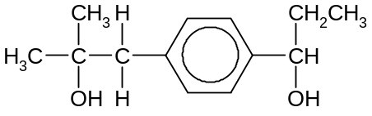  How many isomers (including stereoisomers) would be formed when the compound reacts with hot concentrated sulphuric acid?
 | A | 4 | B | 6 | C | 8 | D | 12

18 | On combustion, 10 cm³ of the vapour of a hydrocarbon Q produces 60 cm³ of CO₂ measured under similar conditions of temperature and pressure.  When Q reacts with hydrogen over platinum catalyst, a compound of relative molecular mass 84 is formed.  What is the formula of Q?
 | A | (CH₃)₂CHCH₂CH₂CH₃
 | B | CH₃CH=CHCH₂CH₂CH₃
 | C | CH₃CH₂CH₂COCH₃
 | D | 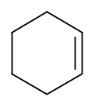

19 | Saccharin is an artificial sweetening agent used in some soft drinks and is manufactured from methylbenzene through a four-step synthesis. Part of the reaction scheme is shown below.  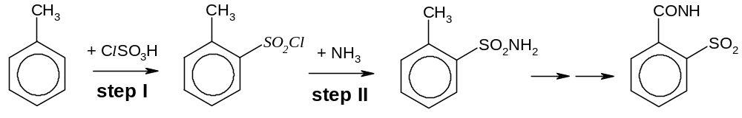  What type of reaction do steps I and II illustrate?
 |  | Step I | Step II
 | A | Electrophilic addition | Nucleophilic addition
 | B | Electrophilic substitution | Nucleophilic substitution
 | C | Nucleophilic addition | Elimination
 | D | Free radical substitution | Electrophilic substitution

20 | Why does the reaction C₂H₅X + OH⁻ → C₂H₅OH + X⁻ take place more rapidly in aqueous solution when X is I than when X is Br?
 | A | The I⁻ ion is less hydrated in solution than the Br⁻ ion.
 | B | The I⁻ ion is a weaker nucleophile than the Br⁻ ion.
 | C | The C−Br bond is more polar than the C−I bond.
 | D | The C−Br bond is stronger than the C−I bond.

21 | Some bromobutanes were separately treated with hot ethanolic sodium hydroxide. Two of them gave the same hydrocarbon, C₄H₆.  From which pair of bromobutanes was this hydrocarbon obtained?
 | A | CH₃CH₂CH₂CH₂Br and CH₃CH₂CH₂CHBr₂
 | B | CH₃CHBrCHBrCH₃ and BrCH₂CH₂CH₂CH₂Br
 | C | CH₃CH₂CH₂CH₂Br and BrCH₂CH₂CH₂CH₂Br
 | D | CH₃CH₂CH₂CH₂Br and CH₃CH₂CHBrCH₃

22 | It has been estimated that for every atom of chlorine generated from a fluorohalogenoalkane in the stratosphere, one hundred thousand molecules of ozone may be destroyed.  Which statement about the chlorine atom gives an explanation of this?
 | A | They are regenerated in a chain-propagation reaction with ozone.
 | B | They achieve high activation energies by absorbing ultraviolet radiation.
 | C | They initiate the ionisation of oxygen molecules.
 | D | They remove ozone from the ozone-oxygen equilibrium.

23 | Compounds X, Y, Z react with sodium, but only one of them reacts with aqueous alkaline iodine. Which of the following combinations is likely to be X, Y, and Z respectively?
 | A | C₆H₅OH, CH₃COOH, (CH₃)₃COH
 | B | CH₃COOH, CH₃COCH₃, CH₃COOCH₂OH
 | C | HOCH₂CH₂OH, HOCH(CH₃)CH₂COOH, CH₃COCH₂OH
 | D | CH₃COOH, (CH₃)₃COH, (CH₃)₂CHOH

24 | Pentaecrythritol is an intermediate in the manufacture of paint.  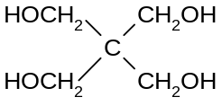  Pentaecrythritol  What deduction can be made from this structure?
 | A | It gives a precipitate with Fehling’s reagent.
 | B | It is soluble in water.
 | C | It is optically active.
 | D | It is dehydrated to an alkene by concentrated sulfuric acid.

25 | Acarol is sold as an insecticide for use on fruit and vegetables.  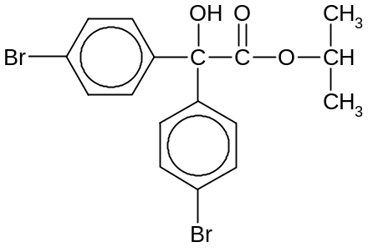  Acarol  The final stage in its manufacture is an esterification.  Which alcohol is used to form the ester?
 | A | di(4-bromophenyl)methanol | B | methanol
 | C | propan-1-ol | D | propan-2-ol

26 | Aldehydes and ketones are produced industrially by the catalytic oxidation of alkenes. For instance, ethanal is manufactured from ethene as shown below.  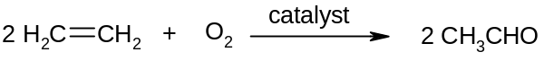  This process is also used industrially with but-2-ene.  Which of the following represents the structure of the compound produced from  but-2-ene?
 | A | CH₃CH₂CH₂CHO | B | (CH₃)₂CHCHO
 | C | CH₃COCH₂CH₃ | D | CH₃CH₂CHO

27 | Aldehydes can undergo addition reactions with a variety of compounds of the form HX according to the following equation:  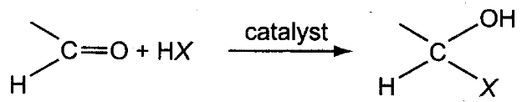  An example of such a reaction is the formation of a cyanohydrin, where X = CN.  Which of the following compounds cannot be obtained by such an addition reaction to an aldehyde, followed by dehydration?
 | A | 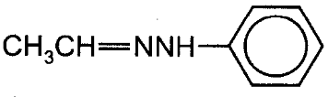 | B | 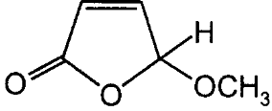
 | C | 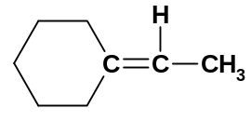 | D | 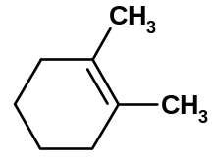

28 | Which of the following, in aqueous solutions of equal concentration, has the lowest pH?
 | A | chlorethanoic acid | B | ethanoic acid
 | C | ethylamine | D | phenol

29 | One industrial preparation of ethanoic acid is the direct carbonylation of methanol using a rhodium catalyst.  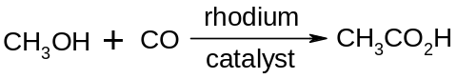
 | Which compound could be used to produce |  | 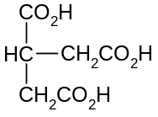 |  |  | by this method?
 | A | 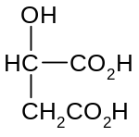 |  | B | 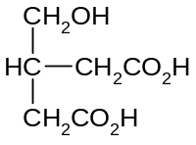
 | C | 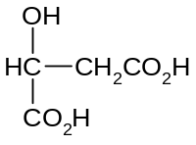 |  | D | 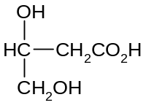

30 | Which of the following pairs of protein segments has an interaction which is likely to be broken due to a change in pH?
 | A | 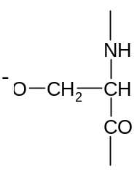 | and | 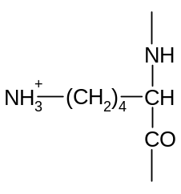
 | B | 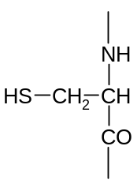 | and
 | C | 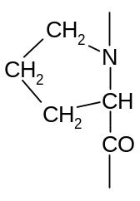 | and | 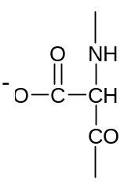
 | D | 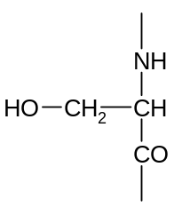 | and

Section B

For each of the questions in this section, one or more of the three numbered statements 1 to 3 may be correct.

Decide whether each of the statements is or is not correct (you may find it helpful to pick a tick against the statements that you consider to be correct).

The responses A to D should be selected on the basis of

A | B | C | D
1, 2 and 3 are correct | 1 and 2 only are correct | 2 and 3 only are correct | 1 only is correct

No other combination of statements is used as a correct response.

31 | Which of the following molecules are polar?
 | 1 | CH₃COCH₃ | 2 | SF₄ | 3 | CO₂

32 | The conversion of graphite into diamond is a non-spontaneous reaction at 298 K. The entropy change of this reaction of this reaction is negative at 298 K.  C(graphite) → C(diamond), ΔG = + 3.08 kJ mol⁻¹  ΔS = − 3.3 J mol⁻¹ K⁻¹  With reference to the enthalpy change, ΔH, of the reaction above, which of the following statements are correct?
 | 1 | The enthalpy change of atomisation of diamond is less endothermic than that of graphite.
 | 2 | The enthalpy change of combustion of diamond is more exothermic than that of graphite.
 | 3 | The bond energy of the carbon−carbon bonds in graphite is greater than that in diamond.

33 | An electrochemical cell is made up of Mg²⁺ / Mg half-cell and the Fe²⁺ / Fe³⁺ half cell. Which of the following statements are correct?
 | 1 | Addition of water to the Fe³⁺ / Fe²⁺ half cell has no effect on the cell e.m.f.
 | 2 | Addition of aqueous sodium hydroxide to the Mg²⁺ / Mg half-cell increases the cell e.m.f.
 | 3 | Increasing temperature has no effect on the cell e.m.f.

The responses A to D should be selected on the basis of

A | B | C | D
1, 2 and 3 are correct | 1 and 2 only are correct | 2 and 3 only are correct | 1 only is correct

No other combination of statements is used as a correct response.

34 | Which of the following can affect the magnitude of the equilibrium constant, K_{p}, of a reversible gaseous reaction?
 | 1 | temperature | 2 | pressure | 3 | catalyst

35 | Which of the following statements are correct for the sequence of compounds below considered from left to right?
  NaF | MgO | AlN | SiC
 | 1 | The bonding becomes more covalent.
 | 2 | The difference in electronegativity between the elements in each compound decreases.
 | 3 | The formula-units of these compounds are isoelectronic.

36 | A catalytic converter is fitted into the exhaust system of a car. Surfaces in a catalytic converter are coated with platinum and rhodium catalyst.  Which of the following reactions could take place on the surface of the catalyst?
 | 1 | hydrocarbons + oxides of nitrogen → carbon dioxide + water + nitrogen
 | 2 | carbon monoxide + oxides of nitrogen → carbon dioxide + nitrogen
 | 3 | carbon monoxide + hydrocarbons → carbon dioxide + water

The responses A to D should be selected on the basis of

A | B | C | D
1, 2 and 3 are correct | 1 and 2 only are correct | 2 and 3 only are correct | 1 only is correct

No other combination of statements is used as a correct response.

37 | 2-methylbuta-1,3-diene can be polymerised to make synthetic rubbers. The structure of this monomer is shown below.  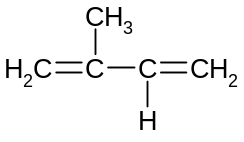  Which of the following statements about 2-methylbuta-1,3-diene are correct?
 | 1 | It is exhibits stereoisomerism.
 | 2 | It decolourises aqueous bromine.
 | 3 | It undergoes electrophilic addition reactions.

38 | Which of the following are properties of fluoroalkanes?
 | 1 | They are likely to contribute to the depletion of the ozone layer.
 | 2 | They are less reactive than the corresponding chloroalkanes.
 | 3 | They may be used as aerosol propellants.

39 | The structure of compound A is shown below.  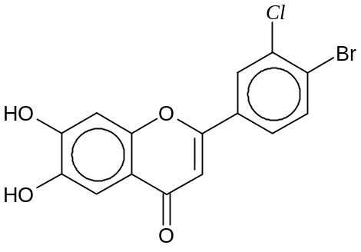  What types of reactions will compound A undergo?
 | 1 | neutralisation
 | 2 | electrophilic substitution
 | 3 | nucleophilic substitution

The responses A to D should be selected on the basis of

A | B | C | D
1, 2 and 3 are correct | 1 and 2 only are correct | 2 and 3 only are correct | 1 only is correct

No other combination of statements is used as a correct response.

40 | Phenyl ethanoate undergoes acid hydrolysis in the presence of water labelled with the ¹⁸O isotope.  Which of the following products are formed?
 | 1 | CH₃CO¹⁸OH
 | 2 | 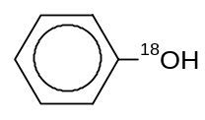
 | 3 | 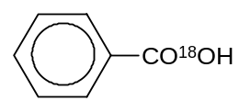

~ END OF PAPER ~

